MACH4METAL

metalworking machinery
Transito 21
6909 DA BABBERICH Netherlands
Tel. +31 (0)316-247123
Fax: +31 (0)316-247956
info@mach4metal.com
www.mach4metal.com

Bank No : 66.52.13.883
IBAN : NL33 INGB 0665 2138 83
BIC : INGBNL2A

CNC Profile bender PBT ARKUS 12
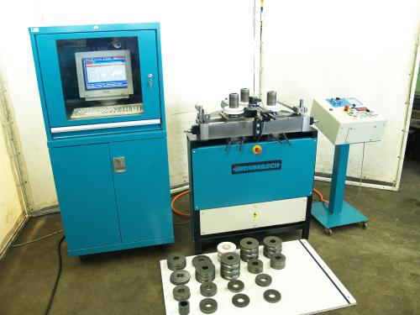
- Make : PBT - Swiss
- Typ : Arkus 12
- Mach. No. : 0060
- Age : 1997

- Capacity X axis : 12 ton
- Speeds till : 18 Rpm
- Vario speeds : 5 – 100 %
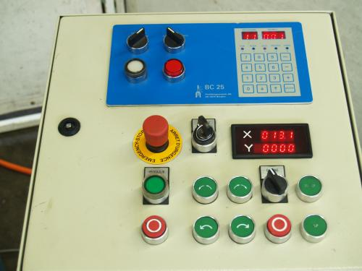
- Torq moment : 200 Nm

- Upper rolls adj. : 256 – 518 mm
- Max. profile height: 100 mm
- Roll shaft Ø : 40 mm
- Stroke : 200 mm

- CNC Control system BC 25 PC 100
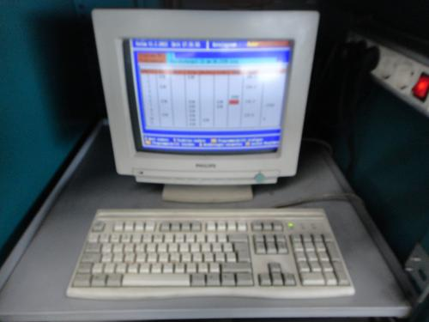
- Dimensions:
- Length : 820
- Width : 950
- Height : 1.125
- Weight : 340 kg
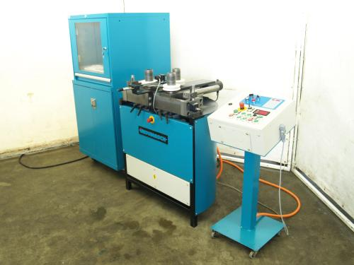
- Capacity:
- Flatt 30/10 x R Ø 300 or 70/12 x R Ø 600
- Round massif Ø 30 x R Ø 300
- Pipe Ø 60 x R Ø 600
- UNP 80 x R Ø 800
- I-PE 60 x R Ø 900

Please Note: The above information has been obtained to the best of our ability and belief from, and from the manufacturers where possible. It is given in good faith, but its accuracy can not be guaranteed. Accordingly, it will not form a representation or constitute contractual terms. We advise you to check any vital details!

